Topic 2 Exercise

- Each female horseshoe crab has a male crab attached to her in her nest. There is a study investigated factors that affect whether the female crab had any other males, called satellites, residing near her.
Data fields:
crab: crab id
sat: number of satellites
y: had or had no satellites
weight: weight of the crab in kilogram
width: shell width in centimeter
color: crab color – 1, medium light; 2, medium; 3, medium dark; 4, dark
spine: spine condition – 1, both good; 2, one broker; 3, both broken

- Read the text data file “Crabs.dat” into R. Describe the data.

Satellites | Number
Y | 111
N | 62
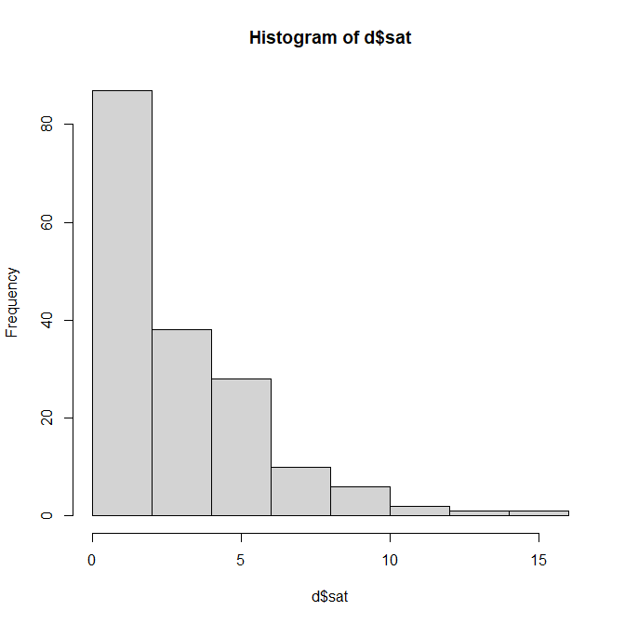

- Identify the factors that affect whether the female crab had any satellites residing near her (Using logistic regression).
- Univariate analysis resulted in significant factors of weight, width, and color. Spine condition is not significant.
- Stepwise selection using BIC resulted in univariate model (~Width) to be the best fit.
- Stepwise selection using AIC resulted in multivariate model (~Width+color) to be the best fit.
- Hosmer-Lemeshow test is not significant, which indicates good fit.

- Identify the factors that affect whether the number of satellites the female crab had residing near her (Using Poisson regression and negative binomial regression).

- Univariate analysis resulted in significant factors of weight, width, spine, and color.
- Stepwise selection using BIC resulted in univariate model (~Weight) to be the best fit.
- Stepwise selection using AIC resulted in multivariate model (~Weight+color) to be the best fit.
- Over-dispersion test is significant, which indicates negative binomial regression fits better than Poisson regression.

